SOCKET IO

1. Used for getting realtime updates.
2. 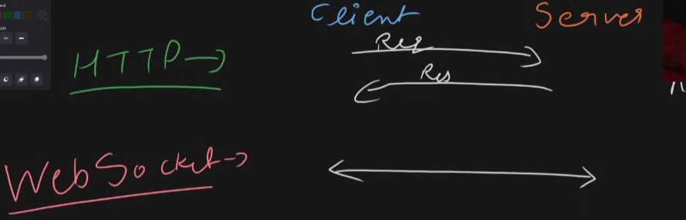
3. When using http request what happens is that when you make a request to the server client side sends request to the backend server for the query and gets response from the server. But in case of websockets connection is build between client and server where both can send anything based on work they are assigned to do and events driven response are received from the server where without polling the server to reply it can send response when a event is triggered.
4. 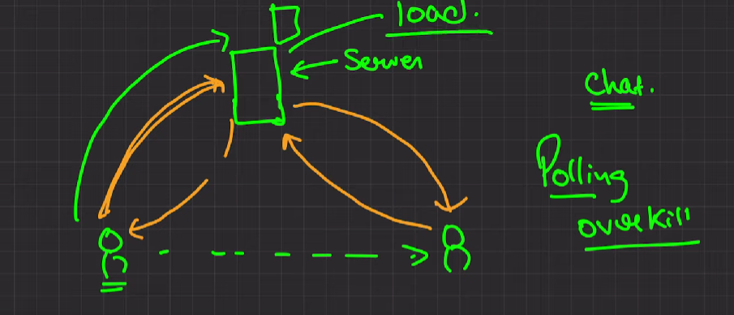
5. What is happening here is that when one person sends a message it goes to server and other person keeps asking server about if there is message for him and as soon as server gets a message it responds to other user that there is a message for you from the other person and this process is known as polling where you keep asking server repeatedly about if there is some message for him or not.
6. Polling is overkill when multiple clients are requesting the server every second which creates a lot of load on the server.
7. In websocket process what happenes is that client ask server to make a web socket connection with it using some upgrade method.This leads to bidirectional connection.
8. 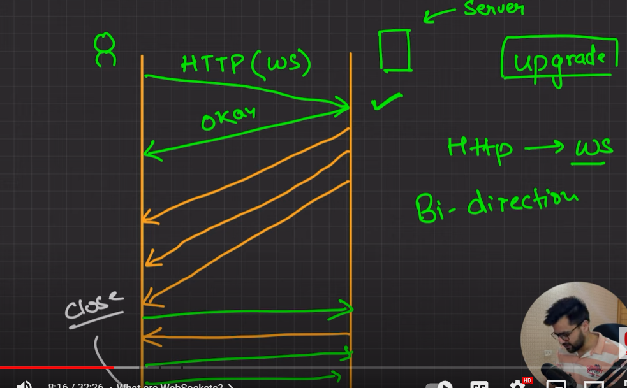
9. 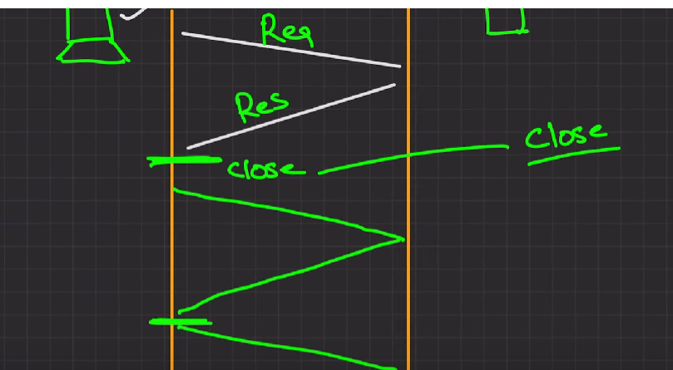
10. In simple req res we are closing the connection with server everytime our req is fulfilled.
11. 
12. To implement it in nodejs we have socket.io library which makes it easy to connect .
13. We cannot attach socket.io directly with express so we use http module to do so i.e. we cannot directly do app.listen
14. SO we make a server using http module as shown below.
15. 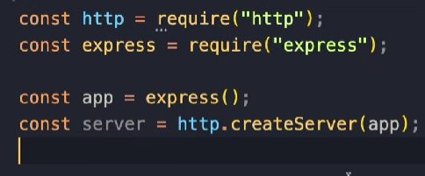
16. App.use(express.static(‘public’)) uses below.
17. 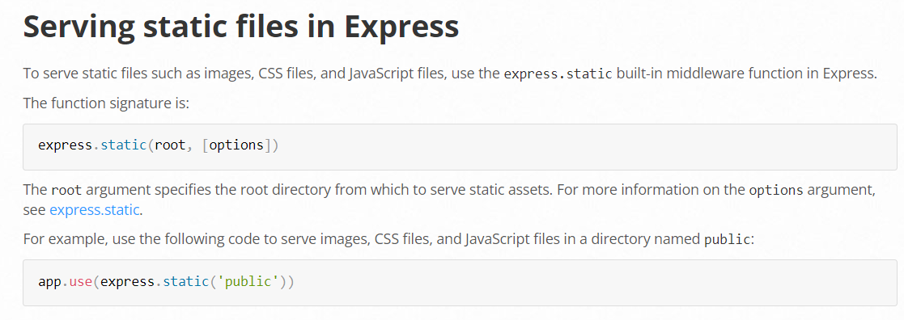
18. 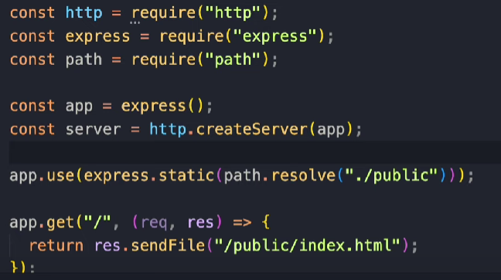
19. Above is a simple way to initialize a simple chat app on our server.
20. Installing socket.io on frontend is also a necessity to build a connection
21. 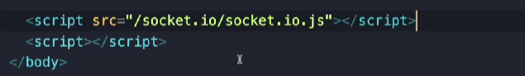
22. Frontend code
23. 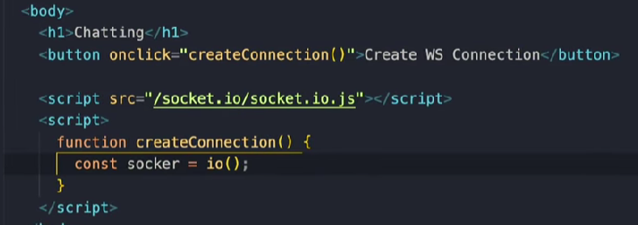
24. It is used to send message using socket.
25. 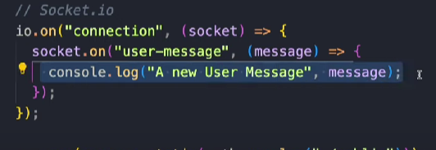This message stayed with server and it consoles it but we want message to go to every client.
26. 